VISVESVARAYA TECHNOLOGICAL UNIVERSITY


JNANA SANGAMA, BELAGAVI– 590018, KARNATAKA, INDIA
A MINI PROJECT REPORT
on
“ANNAMITRA”
Left Over Food Sharing App
Submitted in partial fulfilment of the requirements for the award of
BACHELOR OF ENGINEERING
in
ARTIFICIAL INTELLIGENCE & MACHINE LEARNING
Submitted By
Name USN
POORVIKA A S 4VP23AI032
RAKSHITHA PRABHU 4VP23AI038
SHRADDHA S J 4VP23AI046
YASHASVI A RAI 4VP23AI063
Under the Guidance of
Prof. Abhishek Kumar K
HOD


DEPARTMENT OF ARTIFICIAL INTELLIGENCE & MACHINE LEARNING
VIVEKANANDA COLLEGE OF ENGINEERING & TECHNOLOGY
[A Unit of Vivekananda Vidyavardhaka Sangha Puttur (R)]
Affiliated to Visvesvaraya Technological University and Approved by AICTE New Delhi & Govt., of Karnataka
Nehru Nagar, Puttur - 574 203, DK, Karnataka, India.
NOVEMBER 2025

VIVEKANANDA COLLEGE OF ENGINEERING & TECHNOLOGY
[A Unit of Vivekananda VidyavardhakaSangha Puttur (R)]
Affiliated to Visvesvaraya Technological University and Approved by AICTE New Delhi & Govt. of Karnataka
Nehru Nagar, Puttur - 574203, DK, Karnataka, India

DEPARTMENT OF ARTIFICIAL ENGINEERING & MACHINE LEARNING


CERTIFICATE
Certified that the mini project work entitled “ANNAMITRA” Left Over Food Sharing App is carried out by Ms. Poorvika A S, Ms. Rakshitha Prabhu , Ms. Shraddha S J, Ms. Yashasvi A Rai bearing USNs 4VP23AI032, 4VP23AI038, 4VP23AI046 and 4VP23AI063 respectively bonafide students of Vivekananda College of Engineering & Technology, Puttur in partial fulfilment for the award of Bachelor of Engineering in Artificial Intelligence & Machine Learning of the Visvesvaraya Technological University, Belagavi during the year 2025-26. It is certified that all corrections/suggestions indicated during Internal Assessment have been incorporated in the report deposited in the departmental library.
The project report has been approved as it satisfies the academic requirements in respect of Project work prescribed for the said Degree.

Signature of the Guide Signature of the Miniproject Signature of the HOD
Coordinator
Asst.Prof. Nidhishree M P Prof. Ajay Shastry C G Prof. Abhishek Kumar K

DECLARATION

We, Ms. Poorvika A S (4VP23AI032), Ms. Rakshitha Prabhu (4VP23AI038), Ms. Shraddha S J (4VP23AI046), Ms. Yashasvi A Rai (4VP21AI063) students of B.E. 5th Semester in Artificial Intelligence & Machine Learning, Vivekananda College of Engineering & Technology, Puttur, hereby declare that the project work entitled “Annamitra-LeftOver Food Sharing App” has been carried out by us at VCET, Puttur, under the guidance of Asst.Prof. Nidhishree M P, Assistant Professor, Department of Artificial Intelligence & Machine Learning, Vivekananda College of Engineering & Technology, Puttur, and submitted in partial fulfillment of the requirements for the award of degree in Bachelor of Engineering in Artificial Intelligence & Machine Learning by Visvesvaraya Technological University, Belagavi during the academic year 2025-2026.

Name of the students | USN | Signature with date
Poorvika A S | 4VP23AI032
Rakshitha Prabhu | 4VP23AI038
Shraddha S J | 4VP23AI046
Yashasvi A Rai | 4VP23AI063

Date:
Place: Puttur

ACKNOWLEDGEMENT

We take this opportunity to express our deep heartfelt gratitude to all those people who have helped us in the successful completion of the project.

First and foremost, we would like to express our sincere gratitude to our guide, Prof. Abhishek Kumar K for providing excellent guidance, encouragement and inspiration throughout the project work. Without his invaluable guidance, this work would never have been a successful one.

We would like to express our sincere gratitude towards our project coordinator, Prof. Ajay Shastry C G, Assistant Professor, Department of Artificial Intelligence & Machine Learning, for his guidance and inspiration.

We would like to express our sincere gratitude to Head of the Department, Department of Artificial Intelligence & Machine Learning, Prof. Abhishek Kumar K, for his guidance and inspiration.
We would like to thank our Principal, Dr. Mahesh Prasanna K for providing all the facilities and a proper environment to work in the college campus.

We would like to thank our management for providing the necessary infrastructure to carry out the project work

We are thankful to all the teaching and non-teaching staff members of Artificial Intelligence & Machine Learning Department for their help and needed support rendered throughout the project.

ABSTRACT

ANNAMITRA – Leftover Food Sharing App: This is a mobile-based application developed with an objective to reduce food wastage and help needy people by creating a bridge between food donors and receivers. In today's world, a lot of food from homes, restaurants, and events goes to waste while many people struggle to get even one proper meal. ANNAMITRA solves this problem by bridging donors, such as individuals, hotels, and event organizers, with the receivers, like NGOs or poor people who need food. Donors can upload pictures of leftover food, and then, with the use of AI technology, it identifies whether the food is Veg or Non-Veg. The details, like food type, quantity, and location, are stored using Flask and SQLite, while the Haversine formula helps find nearby receivers for quick and easy food pickup. The app ensures safety and builds trust among verified users who can only donate or receive food through it. It is simple to use, secure, and can be accessed by any person who owns a smartphone. In the future, ANNAMITRA can be upgraded by integrating delivery partners, including notifications, NGO expansion, and AI-based demand prediction. All in all, the app not only helps in reducing food wastage but also spreads awareness about sharing food and building a caring, responsible society with the help of technology.

TABLE OF CONTENTS

Title | Page No.
List of Figures | I
List of Tables | II
List of Abbreviations | III
CHAPTER 1 INTRODUCTION | 1
1.1 Introduction to the project | 1
1.2 Existing System | 1
1.3 Proposed System | 2
1.4 Scope of the Project | 3
1.5 Objectives of the Project | 3
1.6 Organization of The Report | 4
CHAPTER 2 LITERATURE SURVEY | 06
2.1 Summary of Literature Survey | 11
CHAPTER 3 ANALYSIS AND REQUIREMENT SPECIFICATION | 14
3.1 Introduction | 14
3.2 Existing System | 14
3.3 Non-Functional Requirements | 15
3.4 User Interface Requirements | 16
3.5 Software Requirements | 17
3.5.1 TensorFlow | 17
3.5.2 Keras | 17
3.5.3 OpenCV | 17
3.5.4 Numpy | 18
3.6 Hardware Requirements | 18
CHAPTER 4 SYSTEM DESIGN | 19
4.1 Introduction | 19
  - Overview of the Proposed System 19
  - Block Diagram of Annamitra 20
CHAPTER 5 SYSTEM IMPLEMENTATION 22
  - Introduction 22
  - Algorithm Used 22
    - Convolutional Neural Network (CNN) 22
    - Image Pre-processing and Augmentation 23
    - Feature Extraction 23
  - Implementation 24
    - About Dataset 24
    - Workflow 25
CHAPTER 6 RESULT AND DISCUSSIONS 26
  - Snapshots 26
CHAPTER 7 CONCLUSION AND FUTURE
SCOPE 32
  - Conclusion 32
  - Future scope 32
REFERENCES 35

LIST OF FIGURES

Figure No. | Title | Page No.
4.3. | Block Diagram of Proposed System | 21
6.1 | GUI Window for Annamitra-LeftOver Food Sharing App | 27
6.2 | Displays serve food for veg | 28
6.3 | Displays serve food for nonveg | 29
6.4 | Displays search food for veg | 30
6.5 | Displays search food for nonveg | 31

LIST OF TABLES

Table No. | Title | Page No.
2.1 | Summary of Literature Survey | 11

LIST OF ABBREVIATIONS

Abbreviation Description

AI | Artificial Intelligence
ML | Machine Learning
CNN | Convolutional Neural Network
ReLU | Rectified Linear Unit
SQLite | Structured Query Language Lite
Flask | Python Web Framework
HTML | HyperText Markup Language
CSS | Cascading Style Sheets
API | Application-Programming Interface
OSM | OpenStreetMap

CHAPTER 1

INTRODUCTION

Introduction to the Project

In today’s busy world, too much good food is wasted while many people are still hungry. Every year, massive amounts of food are thrown away. This costs a lot of money and creates a big problem for the environment. The simple old-fashioned ways of donating leftover food are usually too slow and the food often spoils before it reaches anyone.
The ANNAMITRA project which we call the "Left Over Food Sharing App" is a smart tech-based answer to this problem. It is designed as one easy-to-use digital platform that quickly connects people who have extra food (like restaurants and homes) with people who need it (like charities or individuals).The most important part of ANNAMITRA is the use of Artificial Intelligence (AI) and Machine Learning (ML), specifically a Convolutional Neural Network (CNN). This smart technology does two key jobs:
Dietary Classification: When a donor uploads a picture of the food, the CNN instantly analyzes the image. It figures out the food type and most importantly if it is Vegetarian (Veg) or Non-Vegetarian (Non-Veg). This makes sure that recipients receive food that matches their dietary needs right away. Fastest Match Finding: The system takes the food details and the donor's exact location. It then uses a math rule called the Haversine formula to quickly calculate the shortest distance to all nearby receivers. This fast, planned matching ensures the extra food gets to the closest person quickly, keeping it fresh and avoiding waste. ANNAMITRA uses digital tools and smart planning to turn an unorganized effort into a strong, reliable system that helps the community, reduces waste, and supports people in need.

  - Existing System

In the current system food donation is mostly done through manual communication or informal methods. People who want to donate leftover food usually contact nearby NGOs, orphanages or volunteers through phone calls or social media. These traditional methods are slow and unorganized. Many times, food donors are not aware of who actually needs food in their area and as a result good food often goes to waste.There are a few mobile apps and organizations that try to connect donors and receivers, but they are limited in features. Most of these platforms do not use Artificial Intelligence (AI) or location-based systems to make the process faster. In such systems, users have to manually enter food details, location, and type, which takes time. There is also no way to automatically classify food as vegetarian or non-vegetarian. Because of this the chances of mismatched or delayed donations are high. Moreover, existing systems do not focus on real-time tracking or quick matching between donors and receivers. The lack of smart features like automated classification, distance calculation, and notifications makes them less efficient. This leads to slow response time, and often, the food becomes unusable by the time it reaches those in need.
Overall, the current food donation process is less effective because it lacks automation, proper coordination, and real-time connection between donors and receivers. This is why a smarter AI-based system like ANNAMITRA is needed to make the process easier, faster, and more reliable. In the current system food donation is mostly done through manual communication or informal methods. People who want to donate leftover food usually contact nearby NGOs, orphanages or volunteers through phone calls or social media. These traditional methods are slow and unorganized. Many times, food donors are not aware of who actually needs food in their area and as a result good food often goes to waste.

  - Proposed System
The ANNAMITRA – Left Over Food Sharing App is designed to solve the problems faced in the existing food donation process by using modern technology. It provides a smart, automated, and easy-to-use digital platform that connects food donors and receivers directly. The system uses Artificial Intelligence (AI), Machine Learning (ML), and location services to make food sharing faster more accurate, and reliable.
In this system, donors can upload details of the food they want to share, such as food name, quantity, and location, along with a picture. When the image is uploaded the app uses a Convolutional Neural Network (CNN) model to analyze the photo and automatically identify the food type. It also classifies the food as Vegetarian or Non-Vegetarian. This automatic categorization helps receivers quickly decide what kind of food is available before requesting it.The system also uses live location tracking with the help of GeoPy and OpenStreetMap API. This allows the application to show nearby food donations based on the receiver’s location. The distance between the donor and receiver is calculated using the Haversine formula which ensures that the nearest available food is shown first. This helps in reducing delivery time and prevents food from getting spoiled.
All data such as user details, food information, and locations are stored securely in a
SQLite database. The backend of the system is developed using Flask which handles user authentication, data storage, and communication between users and the AI model. The system ensures that all user information and food details are safely managed. Compared to the existing manual process, this system is faster, more accurate, and fully automated. It reduces human effort and ensures that leftover food reaches people in need before it goes to waste. Overall, ANNAMITRA creates a smart, efficient, and community-driven platform for responsible food sharing.

  - Scope of the Project
This project has a wide scope as it aims to reduce food wastage and connect donors with people who need food in a simple and organized way. It can be used by individuals, restaurants, hotels, event organizers, and NGOs to share leftover food through a web or mobile platform. The system uses Artificial Intelligence to identify food type and category and location tracking to show nearby donations which makes the process quick and efficient. All user and food details are securely stored in a database ensuring smooth data management. In the future the app can be expanded to include delivery partners, volunteer groups, and automatic pickup scheduling to make food sharing even easier. It can also generate useful reports showing the total food shared and the number of people helped. By reducing food waste the project supports sustainable living and encourages social responsibility. Overall, ANNAMITRA has the potential to grow into a complete digital system that helps create a hunger-free and eco-friendly society.

  - Objectives of the Project
The main objective of the Annamitra-Left Over Food Sharing App is to minimize food wastage through connecting food donors to receivers by providing an easy-to-use digital platform. In the system, users will be able to register and log in, post leftover food quickly and safely. For classification of food as Veg or Non-Veg, this project uses Artificial Intelligence with a Convolutional Neural Network model. Also, the application's backend has been built upon the Flask framework, using an SQLite database for storing data securely. It further incorporates OpenStreetMap API and Haversine formulae for real-time display of the location of donors so that receivers can easily find nearby food. Overall, the project focuses on designing a smart and reliable system that contributes positively towards social welfare by reducing food wastage effectively.

  - Organization of the Report
Report is organized in a such away that it include multiple chapters ,each containing sections and subsections.
Chapter 1 introduces the project and gives an overall idea about the ANNAMITRA – Left Over Food Sharing App. It explains the growing problem of food wastage, the main goals of the project and how Artificial Intelligence and Machine Learning are used to make the food-sharing process smarter and faster. The chapter also highlights the motivation, objectives, and scope of the project.
Chapter 2 provides the literature survey explaining existing systems and related research work. It reviews different methods and tools that are currently used for food donation and classification. This chapter also compares traditional systems with the proposed ANNAMITRA system and shows how AI-based automation and location tracking make it more efficient.
Chapter 3 focuses on the system design and architecture. It explains the various modules, including user management, food detection using CNN, and location-based matching. The chapter also includes diagrams like data flow diagrams and use case diagrams to visually describe how the system works internally.
Chapter 4 discusses the system implementation, covering both the software and hardware requirements. It describes how the backend was developed using Flask how the AI model was trained using TensorFlow and Keras and how different components were integrated to form a complete working system. Screenshots and output results of the working application are also presented in this chapter.
Chapter 5 presents the results, advantages, and applications of the system. It summarizes the key achievements of the ANNAMITRA app such as accurate food classification, easy donation process, and real-time food tracking. This chapter also discusses the project’s benefits, future scope, and concludes by emphasizing how the
system contributes to reducing food wastage and helping people in need. The References section lists all the books, research papers, websites, and online materials that were used while developing and studying the project.

CHAPTER 2

LITERATURE SURVEY

Salah Uddin and Fozlay Rabby Ansary et al[1] wrote an article which describe a very innovative technical solution to a growing challenge of food waste. They referred to the amount of food wasted each year, that is still in safe to eat, is staggering, and the economic and ecological impact of food waste is a significant concern. They proposed a mobile system based on the Internet of Things (IoT) that connects consumers of extra food waste to consumers that need food. The proposed system consists of a mobile food sharing software application, cloud server, and smart food collection box that has weight and temperature sensors and a cooling system. It includes a secure access PIN to collect the food. The system is straightforward. The donor enters the extra (safe, and healthy) food they have, and at the same time, a real-time notification is sent to the recipient of available surplus food, indicating to the recipient they can pick up food from the food collection securely. They reported the system facilitated a food-sharing process that was more reliable, quicker, and safer. They claimed they had more trust as they received feedback through the app. Internet access and smartphone are required.

Priya Tushar Mohod et al [2] The article proposed and published in 2024 in Electronics, introduces a mobile-based system to reduce food waste that occurs in workplace settings. The authors acknowledge that while digital food sharing applications exist (i.e. OLIO and Too Good to Go), they are mainly focused on households and communities, and not directly on the surplus or unwanted food in corporate environments. The app described in this paper uses cloud-enabling technologies to allow a workplace to share homemade, unspoiled dinners with coworkers. The front-end was designed in the Flutter framework, back-end work was done in Spring Boot, and MySQL was used for database administration, while AWS cloud capabilities were used to safely store and access images and other information, while keeping safety in mind. The app included supplier and consumer roles to post and search for meals, verify corporate email addresses for safety, logging in using an OTP, and in-app communication using Firebase. The paper discusses a study using a user evaluation from 100 corporate participants.
Jiequan Hong et al [3] The manuscript published in the British Food Journal presents a systematic literature review of “Mobile apps for reducing food waste at different levels of the supply chain”. The authors identify a main issue—is that in spite of the vast scale of global food waste and loss, we do not know much about apps, their impact reduction, food waste; their impact on food poverty; and what level of supply chain they are undertaken. To remedy of this, the authors apply a three-part methodology (planning, conducting, and reporting), that is structured, based on protocols of review of literature: a search of academic databases for relevant keywords and phrases (i.e., "mobile app", "food waste" etc.), filter, review, select articles published between 2007 - 2022, and synthesis findings regarding areas of study, type of impact and supply chain (Proposed Solution / Methodology). The authors found that the review revealed that most studies focused on consumption and procurement levels of the supply chain, many app were undertaken in developed countries, and most of the themes discussed were around innovation management, platform performance/acceptance and redistribution models. The authors acknowledge some limitations including, many studies were qualitative.

Arfandi Andres et al. [4] In a paper presented at the 2022 International Conference on Artificial Intelligence and Smart Energy (ICAIS 2022), the authors summarize an innovative approach to solving the current issue of edible food waste while feeding hungry people. The introduction of the paper explains the similar problem of food waste simultaneously taking place at events, restaurants, etc., with lots of people struggling with hunger. The authors created Food LifeSavr - a smartphone app that relieves the responsibility of sharing food, and organizes potential donors, courier, and food recipients. The online process of development refers to user-case and class diagrams of the system design. The system design to an organized food-listing system sets forth modules for donor registration for food listing, a courier to deliver the donated food, real-time tracking of food delivery, and visual documentation with photos to limit dishonesty in the process. The application includes a donor forum section for donor-to-donor communications to build community and transparency. The study findings concluded that while the platform expedited the donation process to be able to empower donors to give to food sharing groups with confidence, the system involved accountability through real-time delivery tracking.
Christina Varghese et.al [5] The article presents a mobile-based system focused on reducing food waste while simultaneously addressing the state of hunger through the redistribution of food. The authors highlight the issue of large quantities of foods that are safe to consume being wasted on a daily basis by restaurants, events and grocery stores, while many individuals continue to experience food insecurity - A problem that has been worsened by the COVID-19 pandemic. In response to this, the authors proposed the SeVa app, which acts as an intermediary tool to connect donors to recipients, seamlessly providing listings with excess surplus food in real time on their smartphone application. The design of the app utilized principles of human-computer interaction, integrating IoT, to allow users to input information about food category, quantity, expiration date and freshness level; enjoyers would search for available food items, while in close vicinity. In addition to displaying physically safe and edible food to a user, the app accounts for geo and time-based factors to ensure food safety and relevance. Findings from a user-based evaluation of the app, indicated the application was positively received and considered simple, effective, and useful in sustainable food sharing. However, the authors recognize some limitations in their study as of stage of implementation to prototype and testing with just a small sample.

Miss Neha Dipak Shinde et.al [6] The article proposed in the journal of Emerging Technologies and Innovative Research (JETIR), Vol. 8, Issue 6, June 2021, proposes a food wastage prevention application for Android as a subsequent step in solving the problem. Simplifying the donation of surplus food to the neediest is another key objective of the project. As per the authors' observation, there are a lot of scraps and parts of food that are still suitable for consumption but are discarded from homes, restaurants, and parties every day, just because the process of food donation is not properly systematized. In response to the lack of timely action, the authors have creatively come up with the concept of an app that would enable donors to register, log in, and furnish the details of the food that is available. Administrator verifies this data. Local agents get the data by the administrator, and they after meeting the donors take the food from them and deliver it to the homeless shelters or any other place where it is needed. The method employs various modules such as login and registration, notifications, donor management, receiver details, and admin control, all of which are written in Java and XML on the Android Studio platform. The system is a design that not only makes the donation process easier and safer but also gives access to the donors and the recipients. Here, the app is a very handy tool in the redistribution of food and at the same time, it can be regarded as an influential means through which the social welfare can be elevated by lessening food wastage and extending help to the hunger relief programs. Though the research points out, on the other hand, that there are certain disadvantages such as the only platform the app can run is android, the closeness of the donors and receivers is a factor on which the app's operation is dependent, and if the app wants to be easily scalable, then there is a need for GPS, based automation. Various performance attributes such as availability, response time, and user participation in different sections were used for the evaluation. The authors stated that the application they developed is a feasible way to solve the problem of food wastage. At the same time, it is a great relief to the charitable organizations, and a step towards the enhancement of environmental sustainability. Their idea for the next stage of the features is the addition of such things as barcode or OCR scanning for automatic reading of food expiry dates and also by linking QR codes for ease of tracking and donation chain transparency.

K. N. Naveen Kumar et.al [7] The paper published at IEEE MysuruCon in 2021, revolves around the idea of resolving the paradox of food wastage happening simultaneously with hunger. The authors mention that a large amount of food that is still edible is being thrown away from the likes of houses, restaurants, and parties due to the lack of proper coordination between the donators and the receivers. To solve this problem, they come up with an idea of a mobile and web-based platform which utilizes a new "hunger search" algorithm to find donors to recipients in the nearest neighborhood thereby ensuring that the food distribution is not only rapid but also optimized. As a result, the prototype outputs show that the platform enhances the matching precision, leads to the decrease of leftover food, and promotes the exploitation of surplus resources in a more effective manner. However, the research indicates that there are some disadvantages such as a limited scale of deployment, the necessity for additional manual data entry, and the need for more stakeholders to be involved. The main criteria for identifying the system performance were matching efficiency, response time, and user feedback. The authors concluded the paper by stating that their system is a feasible and scalable solution to the problem of leftover food and proposing as the next steps the integration of real-time data, larger testing areas, and cooperation with NGOs and food organizations for increasing the effect.

Raktim Raihan Prova et.al [8] The paper proposed in 2021, IEEE ICCCNT, comprises “Needy Serve,” a web and mobile platform, to decrease food waste by connecting donors, volunteers, and recipients. The authors recognize that food wastage is not caused by a lack of food but is due to inefficient redistribution systems. Their solution allows donors to put up the surplus food, volunteers to pick it up and deliver it, and recipients to get it through the app, with an option mobile balance donations to cover the logistics costs. Apart from it, the testing with 43 users revealed a high acceptance level of the app-85% for functionality, 75% for navigation, and 73% for design-thus, indicating strong usability. Among the limitations of the research are small-scale testing, dependence on volunteers, and high mobile transaction fees. The evaluation was mainly centered on user acceptance, interface usability, and reliability. The paper findings show that “Needy Serve” is a powerful instrument in food waste reduction and providing help to the needy, and they have plans to upgrade the app for scaling, UI improvement, and expanding beyond food redistribution.

Vahid Jafari-Sadeghi et.al [9] article published in the Journal of Business Research (2021) investigates the effect of digital transformation on technological entrepreneurship and market expansion. The authors point out that the relationship between digital adoption and the generation of entrepreneurial value is still very unclear. The paper links technology readiness, digital exploration, and exploitation with entrepreneurship outcomes through the means of data from 28 European countries and structural equation modeling. The results signify that technology readiness has a good impact on both exploration and exploitation which finally leads to innovation and market expansion. The research is dependent on and limited by cross-sectional data and may be of limited relevance to emerging regions. The study was based on a variety of indicators such as ICT investment, digital innovation, and new venture activity. Besides suggesting future research in emerging countries with longitudinal data for a better understanding, the article concludes with a statement that digital transformation is the driver of entrepreneurship if firms can manage exploration and exploitation concurrently in an effective manner.

John Harvey et.al [10] The paper published in Industrial Marketing Management (2020) argue that apart from reducing food waste, mobile apps like OLIO are also very instrumental in reshaping food redistribution networks. The authors point out that interactions between users in the real world are still mostly hypothetical, even though digital platforms may facilitate contact between donors and recipients. To understand sharing dynamics in the digital world, they conducted a social network analysis of 54,913 food-sharing transactions between 9,054 people over ten months. Conventional reciprocity theories cannot account for digital sharing behavior as actors rarely co-occur, organizations are usually at the exchange intermediaries, and consumers are mostly either givers or recipients. Moreover, the research only looks at one app and one country, does not have demographic data, and cannot verify offline behavior. In addition to these, transaction frequency, user connectivity, and network centrality were among the metrics used in the study.The paper concludes that mobile applications are a major factor in the transition of food distribution networks, but understanding user motives and social dynamics will need more research. It thus suggests that subsequent investigations should be conducted in other platforms and locations.

2.1 Summary of Literature Survey
The literature survey in Table 2.1 examines mobile and AI-based solutions for cutting down on food waste. These studies focus on connecting donors and receivers through intelligent, location-based platforms, though issues of scalability and automation remain.
Table 2.1: Summary of Literature Survey

Author | Title | Features | Pros | Cons
Uddin, M. S., & Ansary, F. R.  (2025) | Share-a-Meal: A Mobile App-based Food Sharing System | App-based food sharing; connects donors & receivers; AI-based categorization | Reduces noise; helps with visual clarity; ideal for diverse conditions | Limited scalability; depends on active users
Mohod, P. T., et al.  (2024) | Meal Box Sharing in Corporate Environments Using Cloud | Cloud-based app for meal redistribution in workplaces | Secure cloud integration; promotes zero waste at workplace | Focused on corporate setting only
Hong, J., Jaegler, A., & Gergaud, O. (2023) | Mobile Apps to Reduce Food Waste in Supply Chains: A Review | Survey of various mobile food waste reduction apps | Provides comparative insights; identifies success factors | Lacks implementation of a specific model
Andres, A., et al.  (2022) | Sharing Food with Goodliffes’ve Smartphone App | Real-time food donation with AI-based alerts | Simple interface; effective food tracking | Limited AI integration; no predictive model
Varghese, C., Pathak, D., & Varde, A. S. (2021) | SEVA: A Food Donation App for Smart Living | Mobile app linking donors and NGOs; geolocation-based | Efficient matching; easy-to-use interface | No ML-based optimization; manual matching
Shinde, N. D., & Patil, A.  (2021) | Designing a Mobile Application for Food Wastage Reduction | App for restaurants to list surplus food | Simple, low-cost approach; focuses on restaurant sector | Lacks automation and AI components
Nukala, S. S., et al.  (2021) | Leftover Food Management System Using Efficient Hunger Search Techniques | AI-based hunger search and food management | Uses ML algorithms for efficient distribution | Complex to implement; requires large dataset
Prove, R. R., et al.  (2021) | Web and Mobile-Based Approach to Redistribute Consumable Food Waste | Combines web & mobile access; cloud storage | Broader accessibility; data backup | Higher maintenance and latency
Mazzuchelli, A., et al. (2020) | Key Factors for a Successful Food Sharing Platform | Study on factors affecting food-sharing success | Identifies design & user trust factors | Theoretical; lacks prototype implementation
Harvey, J., et al.  (2019) | Food Sharing and Waste Reduction via Mobile Apps: A Social Network Analysis | Social network analysis of sharing apps | Highlights community dynamics & influence | No technical or algorithmic development

CHAPTER 3

ANALYSIS AND REQUIREMENT SPECIFICATION

Introduction
In today’s world, one of the biggest problems we see around us is food wastage. Every day, tons of food go to waste in homes, restaurants, and hotels, while many people are still struggling to get even one proper meal. This is something that really made us think about how technology could help make a change. Our project “ANNAMITRA – Leftover Food Sharing App” is designed to bridge this gap between food donors and people who need food. The main idea is simple — instead of letting surplus food go to waste, why not connect the people who have it with those who can use it? With this thought, we developed an application that uses Artificial Intelligence (AI) and Machine Learning (ML) to automatically identify and classify the donated food, and then match it with nearby NGOs or receivers.This chapter explains the complete analysis and requirements of our project. It discusses what problems exist in the current situation, how our system overcomes those issues, and what kind of software and hardware setup is required to make it work effectively. The analysis forms the base for building a well-structured and reliable system.

Existing System
In the current scenario, there is no proper platform that connects food donors with receivers in an organized way. Most of the time, food donation happens manually — people call NGOs, message them, or share details on social media. This method takes time and sometimes the food gets spoiled before it can be collected.Although there are some international food-sharing apps, they are either limited to certain areas or designed for commercial use. They don’t focus on the Indian context or local needs, and many of them require constant internet access and technical knowledge. Moreover, they don’t have AI-based features like automatic food classification or live location tracking.
In short, the existing systems are not efficient enough to handle real-time food donations, especially in smaller towns or rural areas. There is a clear need for a simple, smart, and reliable application that connects donors and receivers quickly, without complicated steps. Our project ANNAMITRA tries to fill this gap by using modern technologies like AI and Flask to make the food-sharing process smooth and automatic

Non-Functional Requirements
Non-functional requirements describe how well the system performs rather than what it does. These qualities ensure the system is efficient, secure, and user-friendly.
- Performance:
The system should process uploaded images and provide results within a few seconds. It should not lag even if several users use the app at the same time.
- Reliability:
The application should give consistent and accurate results every time. All user and donation data must be stored safely in the database.
- Usability:
Since the app is meant for all kinds of users, including those who are not tech-savvy, it should be easy to use with clear instructions and simple navigation.
- Scalability:
The system should be able to handle more users and more food categories in the future without slowing down.
- Security:
The application should protect user information and login details using encryption. Flask-Bcrypt is used to hash passwords and keep them safe.
- Maintainability:
The code and design should be easy to update whenever needed, for example, when adding new features or fixing bugs.
These qualities make sure the system runs smoothly, safely, and remains useful for a long time.

3.1 User Interface Requirements
The user interface (UI) plays a major role in how comfortable and simple the application feels to users. Our goal was to design a UI that is clean, straightforward, and responsive.
The app allows two types of users — donors and receivers (or NGOs). Donors can sign up, log in, and upload an image of leftover food along with some basic details such as the type of food, quantity, and location. The system then predicts whether the food is vegetarian or non-vegetarian using the AI model. On the other hand, receivers or NGOs can log in and see the available food donations near them, along with the pickup location shown on a map.
The interface includes:
- A simple login and signup page
- A donation page for uploading food images and entering details
- A results page showing the predicted food category
- A search page for receivers to find available food
- Map integration for live donor locations
The overall design is built using Flask with HTML templates and integrated with Python code. The layout is kept clean, with minimal text and clear buttons, so users can easily understand how to use it without needing technical knowledge.
3.5 Software Requirements
The software setup is chosen to make sure that both the AI model and the web app work together smoothly.
- Operating System: Windows 10/11, Linux, or macOS
- Programming Language: Python 3.8 or above
- Framework: Flask for backend and web interface
- Machine Learning Libraries: TensorFlow and Keras for training and running the CNN model
- Image Processing Library: OpenCV for capturing, resizing, and processing food images
- Database: SQLite for storing user and donation details
- Security Library: Flask-Bcrypt for password encryption
- Additional Tools: SQLAlchemy for database management and Visual Studio Code for development
All these tools and libraries are open-source, making the project cost-effective and easy to maintain.

3.5.1 TensorFlow
TensorFlow is an open-source deep learning library developed by Google. It is used for training the Convolutional Neural Network (CNN) that identifies food images. TensorFlow helps perform complex mathematical operations quickly and allows the model to give accurate results in less time.

3.5.2 Keras
Keras is built on top of TensorFlow and makes model building much easier. It provides simple functions to define layers, activation functions, and optimizers. We used Keras to train and fine-tune our CNN model that classifies the food into vegetarian or non-vegetarian.

3.5.3 OpenCV
OpenCV is used for image-related tasks such as reading, resizing, and enhancing food images before sending them to the model. It also helps in capturing live images directly through a webcam or mobile camera. This makes real-time food classification possible.
3.5.4 NumPy
NumPy is a Python library for numerical operations. It is used to handle image arrays, perform mathematical calculations, and make data compatible with TensorFlow and OpenCV. It basically helps the system process data faster and more efficiently

3.5.5 Flask / Streamlit
The Flask framework is used to create the web-based application and manage the backend process. It connects all parts of the system — from user login to model prediction and database operations. For demonstration purposes, Streamlit can also be used to create a simple dashboard that shows predictions in a clean and interactive way.

CHAPTER 4

SYSTEM DESIGN

4.1 Introduction
The ultimate purpose of the system design ANNAMITRA-Leftover Food Sharing Application is to develop a quality, smart, and modular system that makes food redistribution easier and more efficient. So, the design of the overall structure was very harmonious in terms of the functionalities of each part, thus enabling a single online ecosystem to connect donors, recipients, and NGOs. Also, it is powered by A.I. technology. Giving away food can be completely automated and additionally, it may be enhanced by machine learning (ML) as well as the use of geo location-based services. Community adoption, through the implementation architecture, of the widely practice is highly scalable, secure, and real-time performative. The ANNAMITRA system's multi-layered architecture includes user interaction modules, backend logic, decision-making with AI, and cloud database integration. Obviously, they are each capable of working independently but can also communicate with each other through APIs and, thus, be able to operate smoothly even if they experience extreme traffic or network

Overview of the Proposed System

The designed system is an application both online and mobile-accessible that serves as a green link between food donors and recipients. This platform makes it possible for the ones having surplus food to openly share the most detailed information (what, how much, when it is going to be used, and where) and, thereby, relieves the receivers in locating the providers or placing orders according to their needs.First of all, quality, location, and time factor are the three aspects against which ML and AI models are perfectly matched to facilitate fair and timely food redistribution.The app is also fitted with features such as instant notifications and location tracking that enable donation pick-up and drop-off to be planned easily and conveniently.

Main elements of the system include:
• User Module – It is the main entity for the performance of registration, login, and authentication of donors and receivers.
• Donation Module – The module, by facilitating donors to provide food details along with pictures and expiration date, is
• Search & Matching Module – The receiver's need for local food donation through searching, filtering, and sending requests is
• AI/ML Module – This module utilizes classification algorithms for the division of food into categories (Veg/Non-Veg) and facilitation best matching suggestions.
• Notification Module – Provides the users with the most up-to-date notifications concerning their orders, confirmations, and the progress of the pickups.
• Database Module – Aims at the secure maintenance of user profiles, food items, and transaction history in Firebase or SQLite.
• Location Services – Depend on the GeoPy and OpenStreetMap APIs for distance calculation and route planning.
The current system is designed to have the capacity to add future features such as the inclusion of delivery partners, a feedback system, and the back-end infrastructure scaling up to be able to handle more users. The use of AI makes sure that food supplies are distributed in an intelligent way and that the amount of wastage is also ​‍​‌‍​‍‌​‍​‌‍​‍‌reduced.

Block Diagram
A block diagram represents graphically a process in a system. It is used to illustrate the sequence of tasks that provide a clear visual overview of the process. So here the flow diagram of System includes Data Collection, Pre-Processing, Feature Extraction, Classification, Disease Identification and User interface and Output.

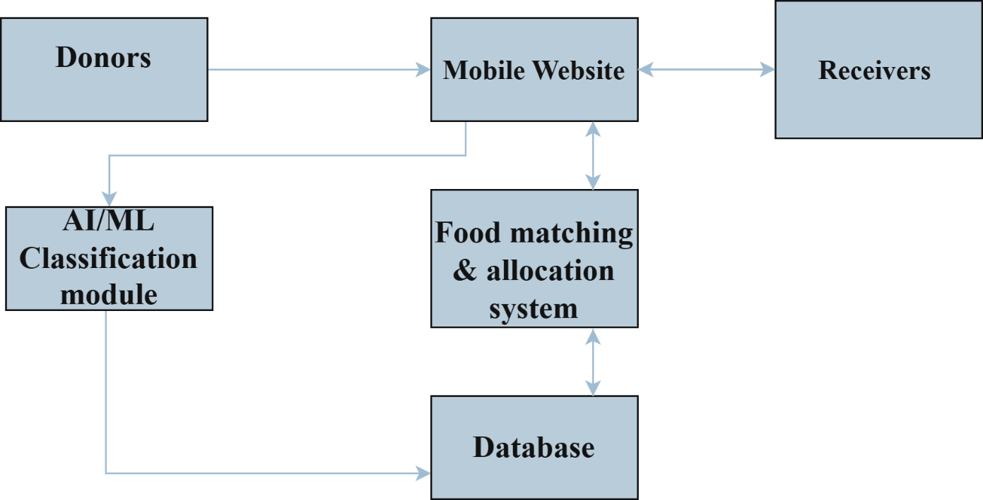
.
Fig 4.3.: System Design for Annamitra-Leftover food sharing app
The system design of the Annamitra-Leftover Food Sharing App shows the flow of the donated food through the system, right from the donors to the receivers. Donors upload the food details and images through the mobile website. This image then goes for processing through the AI/ML classification module, which classifies the particular food item and categorizes it as vegetarian or non-vegetarian. This information will be stored in the database along with other donation details such as quantity and location. The stored data is then utilized by the food matching and allocation system in order to connect available food donations with suitable receivers such as NGOs or individuals in need. Receivers finally access the mobile website, view the available food, and accept the items, thereby completing the donation cycle. This system creates a smooth, automated, and efficient flow of food data between donors, AI processing, database storage, and receivers.

CHAPTER 5

SYSTEM IMPLEMENTATION

Introduction

This design will be converted to a functional website in the implementation phase of the

ANNAMITRA-Left Over Food Sharing App connecting food donors and receivers.

This involves integrating the machine learning model with a user interface, database, and location features into one working system. The project applied a CNN for recognizing and categorizing food items with respect to uploaded images while the framework for the entire functionality was provided by Flask which handles user interaction and data flow. Users are allowed to register themselves, donate food, and search for donations available in their neighborhood . Using the trained CNN model the system automatically categorizes the food as Vegetarian or Non-Vegetarian while the Haversine formula is applied to calculate the shortest distance between donors and receivers. This will involve the creation of a dependable, accurate, user-friendly technological platform to help reduce food wastage.

Algorithm Used
The ANNAMITRA system integrates several algorithms and technologies in performing this food sharing with high accuracy and efficiency. Convolutional Neural Network forms the fundamental algorithm that is employed in recognizing the type of food through the images uploaded by the users. Along with CNN, many other supporting techniques are also employed, including image preprocessing, extraction of features, and optimization methods such as Adam Optimizer. The system calculates the geographic distance between users using the Haversine formula, which makes it easy to connect donors with receivers in a short time.

Convolutional Neural Network (CNN)
The Convolutional Neural Network (CNN) is the primary framework utilized in the ANNAMITRA system. CNN represent a powerful framework for image classification given that they can learn and understand patterns found in images without human intervention. In is used in this project the CNN was trained a large-scale dataset of food imagery labeled as Vegetarian and Non-Vegetarian.
Given an image as input to the model the CNN processes the image through several layers including convolutional layers, pooling layers, and fully connected layers. The convolutional layers detect meaningful features in the original image, such as edges, colors, and textures. The pooling layers help reduce the input image dimensionally in order to speed up the processing. The ReLU activation function increases the model ability to detect more complex features while the fully connected layers combine all processing from the previous layers into one classification of either Veg or Non-Veg.
After training on many food images the CNN can accurately determine and classify new food images into categories even if the conditions of the lighting angle or background changes from when it previously learned about the food images. This comes together to make ANNAMITRA a trustworthy and reliable method of instant and automatic food type detection.

Image Pre-processing and Augmentation
Pre-processing images ensures all images delivered to the CNN model are uniform in format and ready for training or prediction. Each image will be resized to a fixed size of 150×150 pixels and the pixel values will be divided by 255 to bring the values into a range of 0 to 1. This speeds the training process and allows for a more accurate function of the model.To add flexibility to the model data augmentation methods will be used such as rotation, zoom, and flipping. Data augmentation creates a larger training set by making versions of existing images or changing the angle, lighting, or shape. This allows the model a larger range of information to learn parameters to perform more effectively on new images. Preprocessing images and using augmentation makes the ANNAMITRA model more consistent, stable, and accurate for use in food image classification.
    - Feature Extraction
Feature extraction is the step where the system identifies and focuses on the most important details in food images. In the CNN model, this happens automatically through the convolution layers, which slowly learn to recognize different shapes, colors, and patterns
that help tell one type of food from another. The early layers of the model find simple details
like edges, lines, and textures, while the deeper layers recognize more complex patterns such as the overall look and structure of the dish. Once all these features are detected they are combined and sent to the final layers for classification. This process helps the ANNAMITRA model understand the image clearly and accurately identify the type of food.

Implementation
The ANNAMITRA application integrates various technologies to create one comprehensive web-based application. The backend of the application is powered by Flask which manages user logins, form submissions and initiates a request to the trained TensorFlow model. The prediction of food images is done using the TensorFlow/Keras framework while SQLite is a simple lightweight database storing user details, food, and location information.
The app consists of several modules including user/receiver registration, food donation, and food search. Donors are allowed to login to the app, upload their food image, and a few simple details (e.g., quantity and location) before submitting it. Once submitted, the image of the food is processed by the CNN model to predict if it is Veg or Non-Veg. The model predicts the accuracy of the meat classification and the results appear in the database and dashboard for donor view. Receiver users can search for available food to pick-up and the distance from the food donor is computed using the Haversine formula to suggest nearest donors first enhancing the speed and efficiency for both donors and receivers.

About Dataset
The dataset used for training the CNN model contains images of commonly donated Indian food items divided into Veg and Non-Veg categories. Each category includes subfolders with specific dishes like rice, idli, dosa, biryani, chicken, and fish.The dataset was cleaned and organized to remove duplicates and poor quality images. It was then divided into training and validation sets to test how well the model performs. This well structured dataset helps the ANNAMITRA model recognize various food types accurately and make reliable predictions.

Workflow
The workflow of the ANNAMITRA system explains the step by step process that ensures smooth and efficient food donation between donors and receivers.
- Upload Food Image: The donor uploads a picture of the leftover food through a simple web interface and fills in basic details such as name, quantity, and location. The system checks the image format and quality before processing. This makes the donation process quick and simple for everyone.
- Pre-process Image: After uploading the image is resized to 150×150 pixels and normalized between 0 and 1. It is then converted into numerical form so the CNN can read and analyze it. This ensures all images are consistent and improves prediction accuracy.
- Predict Food Type (CNN Model):The processed image is sent to the trained CNN model which identifies patterns and predicts whether the food is Veg or Non-Veg. The Softmax function determines the most likely result and the prediction is displayed within seconds.
- Store and Display Data: Once the prediction is done all details including food name, type, donor name, and location are saved in the SQLite database. These details appear on the donor’s dashboard for easy tracking.
- Search and Display Nearby Food: Receivers can search for available food by entering a keyword or using their location. The system calculates the nearest available food using the Haversine formula ensuring the food reaches receivers quickly while it’s still fresh.
- Food Collection and Completion: After choosing a food item receivers can view the donor’s details and coordinate collection. Once the food is picked up the record is marked as complete closing the donation process efficiently and avoiding food waste.
CHAPTER 6

RESULT AND DISCUSSIONS

Snapshots
A snapshot typically refers to a captured image or representation of a computer screen at a particular moment in time. It can be a screenshot or an image taken by a camera or other imaging device. In the context of software development or testing, a snapshot can also refer to a saved state or configuration of a system or application, often used for debugging or reference purposes.
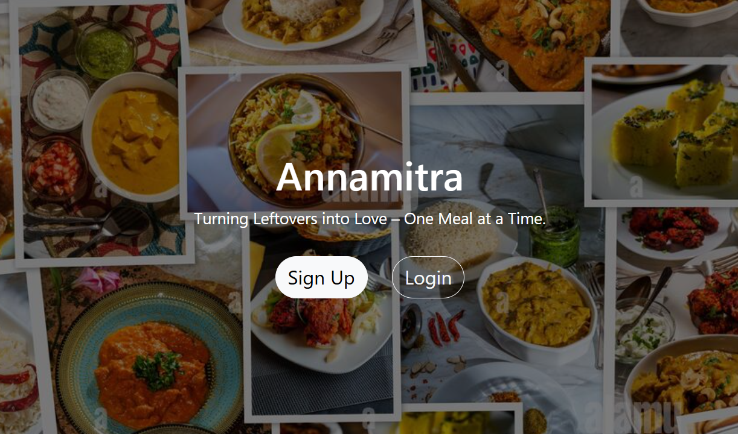

Figure 6.1 GUI for Annamitra-leftover Food Sharing App
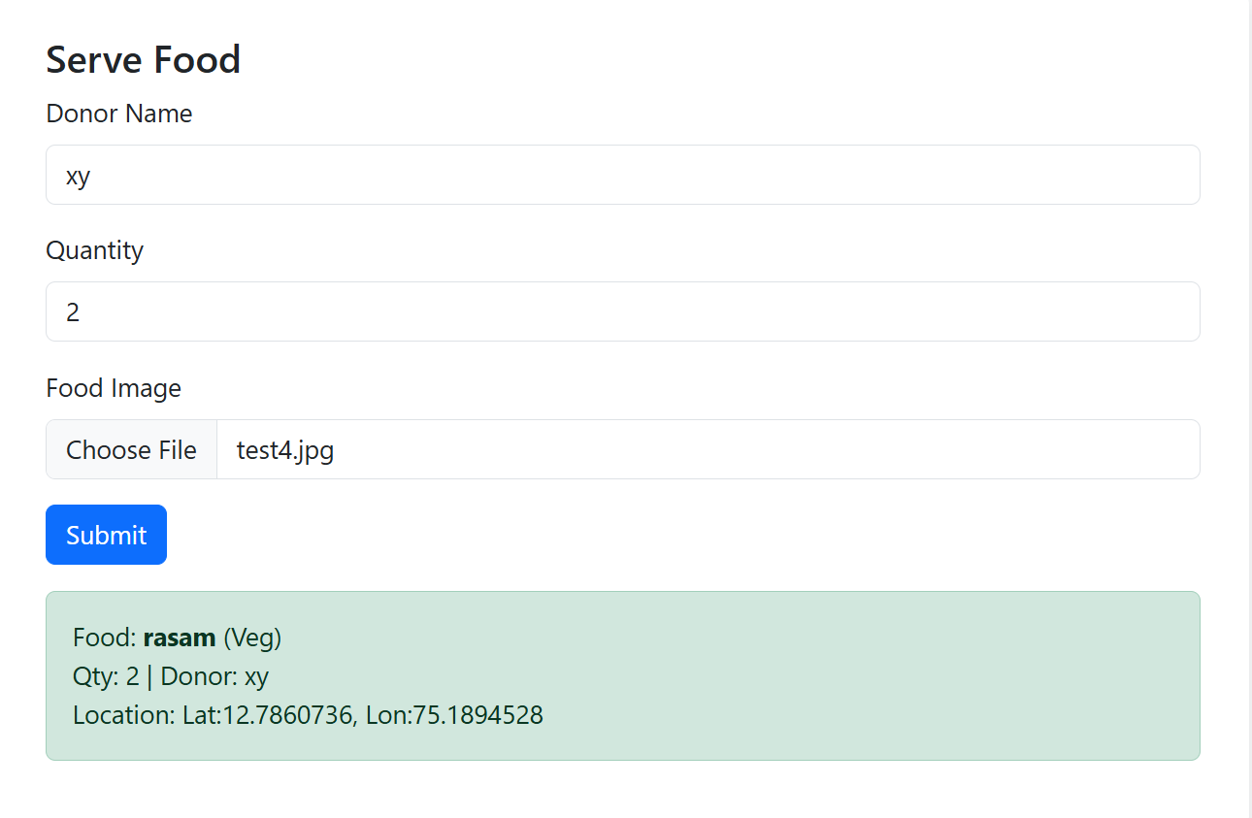
The above fig 6.1 depicts the GUI of the Annamitra – Left Over Food Sharing App. It includes the title of the project, along with the tagline: “Turning Leftovers into Love – One Meal at a Time.” This interface is designed using a clean and simple layout to make it user-friendly for all its users. On the homepage, two options are available: Sign Up and Login. Through these options, both donors and receivers will be able to access the system. When the user opens the app, this page is loaded via the Flask web framework. If a new user selects the option to Sign Up, the registration form stores user details in the SQLite database; existing users log in with authentication encrypted by Flask-Bcrypt. Once logged in successfully, users are taken to the dashboard, where a user can further donate food or search for the availability of donations. The smooth operation of the page confirms that the front-end interface and Flask back-end are properly connected, and the flow of navigation works as expected.
Figure 6.2 Displays serve food for veg
The above fig 6.2 presents the Serve Food page of the Annamitra application. This is the user interface where food donors are required to upload the details of left-over food they want to share. This interface involves input fields for donor name, food quantity, location, and uploading an image of the particular food item. Once the image has been uploaded along with the submission of the form, the data goes to the backend, where the trained CNN model processes the image for the identification of the category of food. Features from the image are extracted by a Convolutional Neural Network through convolution, pooling, and activation layers, and it categorizes the food by using the Softmax output layer. In this case, the picture of Rasam that was uploaded has been correctly recognized as Veg food. The outcome is displayed on the screen with the name and coordinate of the donor, while all information is automatically stored in the SQLite database. The page has been designed using the Flask framework, which links the user's interface to the backend model and database. The whole process right from Upload to Prediction takes only a few seconds, which confirms efficiency. Testing showed the accurate classification of food by the model and non-errorrous storage and retrieval of data. Thus, this figure proves that the Serve Food module works smoothly and effectively, allowing donors to share leftover food in a smart, automated fashion.
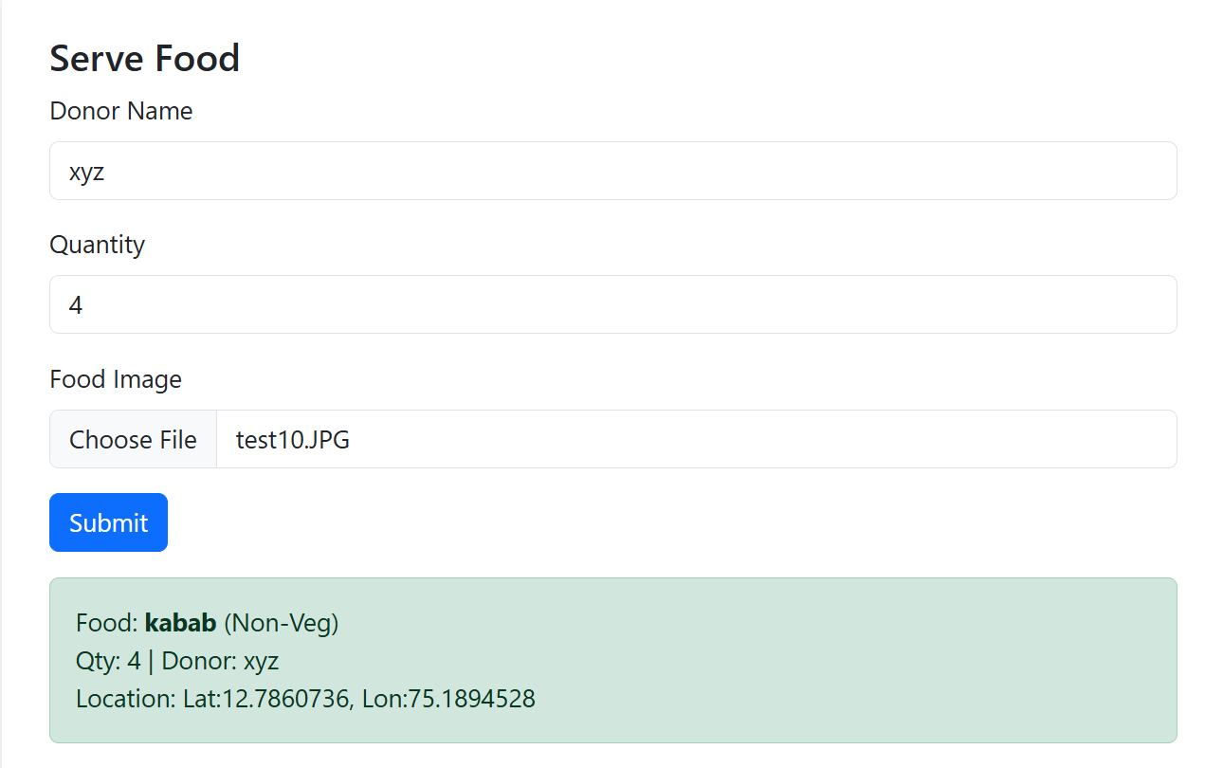

Figure 6.3 Displays serve Food for nonveg
The above fig 6.3 depicts another example of the Serve Food page, which shows how the system handles non-vegetarian food images. In this case, the donor uploads an image of Kabab along with their name, food quantity, and location. Once uploaded, the image is pre-processed by the system and converted into an array format before being passed through the CNN-based image classification model. The model extracts important features such as edges, color, and texture and compares them with its trained dataset to predict the food category. The ReLU activation layer helps detect non-linear patterns, and the Softmax layer assigns probability scores to possible classes. The output is then displayed on the screen, showing that the food is classified as Non-Veg (Kabab). The system also shows the donor’s details and saves all information in the SQLite database for future use. The entire process is handled by Flask, which connects the model, database, and user interface. The application responds quickly and accurately, providing instant results to the donor. This figure confirms that the AI model can successfully distinguish between Veg and Non-Veg food images with high accuracy. The smooth coordination between the Flask server and database ensures fast processing and error-free data storage. Hence, this page proves that the AI model, Flask backend, and database connectivity work together efficiently to achieve reliable and real-time food classification in the Annamitra application.
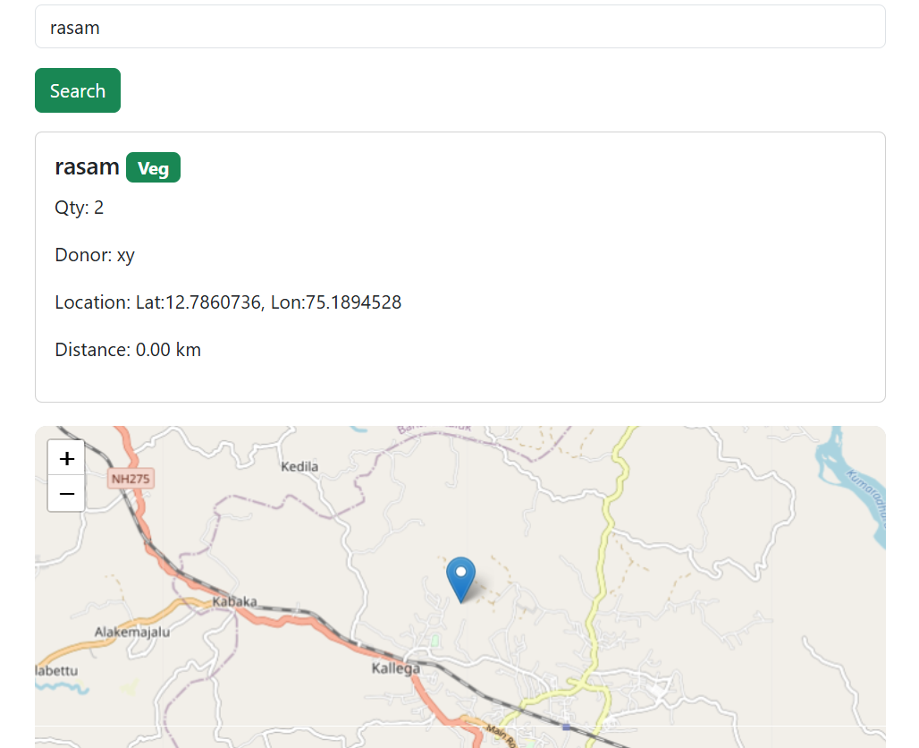

Figure 6.4 Displays Search Food for veg

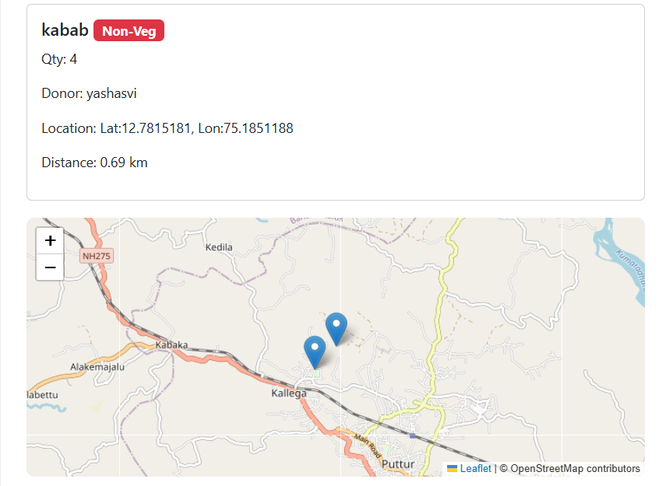
The above fig 6.4 This is the Search Food page of the Annamitra application, where receivers can identify the list of available food donations in their vicinity. Here, the receiver has searched for Rasam. The search request goes to the Flask backend, which in turn queried the SQLite database for records matching the food name. Details like food name, quantity, type, donor name, and location are then displayed on the screen. This application implements the Haversine Distance Formula for calculating the distance between the locations of the receiver and the donor based on their latitude and longitude values. To make the results a bit interactive, it displays a map from the OpenStreetMap API, where a blue marker pin shows the exact location of the donor. This feature helps receivers identify food sources near their location and therefore plan collection accordingly. The query sends to the database, fetching of results, and updating of the map happen instantaneously. While testing, the search for Rasam showed the correct information, and the map loaded without any time delay. This figure provides proof that the search functionality, database connection, and mapping modules are well implemented and work in conjunction with each other, thereby making the system reliable to be used for real-time redistribution of food.

Figure 6.5 Displays search food for nonveg
The above fig 6.5 The Search Food page - result for the receiver searching for a non-vegetarian item like Kabab When the receiver searches for Kabab, the Flask backend fetches all records of Kabab from the SQLite database and presents them on the screen along with other details such as the name of the donor, type of food, quantity of food, and location coordinates. The distance of each donor from the receiver is pre-computed by the system using the Haversine formula, and results are visualized on a map using the OpenStreetMap API. Multiple blue pins will pop up on the map representing different donors who have Kabab available to donate. Each pin will give the exact location of the respective donor, so that the receiver can collect the food from the nearest donor. The application is very interactive and user-friendly. While testing, the search worked fine, and it instantly updated the map and showed accurate donor locations without any delay. It also proves that the data retrieval and map rendering module works perfectly with the Flask server. This figure confirms that multiple donors are handled with real-time results and that the application can handle multiple donors and display the results in real time. Overall, the search and mapping functionalities in the Annamitra application perform accurately and with ease for the receivers to find and collect food from nearby donors with ease, thereby contributing towards reducing food wastage in the community.

CHAPTER 7

CONCLUSION AND FUTURE SCOPE

Conclusion

The project, “ANNAMITRA – Left Over Food Sharing App,” aimed to reduce food wastage and help needy people by effectively utilizing Artificial Intelligence and Machine Learning technologies, which was developed and tested with success. The system will efficiently connect food donors and receivers on a single digital platform, enabling the sharing of leftover food by users in an easy and safe manner. A Convolutional Neural Network model is used in the application for identifying the uploaded food image and classifying the same as either Veg or Non-Veg to ensure that the same is properly categorized before being further distributed. The Flask Framework is used to develop the system backend, handling user authentication, data management, and communication between the front-end and the AI model. SQLite Database has been used to store user details, donation data, and the food record securely, while the OpenStreetMap API and Haversine formula are used to show locations of donors and the distance between donors and receivers. All modules worked perfectly in the tests, and it showed accurate predictions and correct location mapping. The system provided fast and user-friendly interaction for both the donors and receivers. Thus, the project amply demonstrates how a social issue like food wastage can be addressed through the help of technology, which then would turn out to be an efficient and sustainable solution for the community at large. Further Improvement of the Application: In further improvement, the app will try to incorporate delivery partners, real-time notifications, and NGO collaborations in order to make the food sharing easy, accessible, and effective. In simple terms, the Annamitra App fulfills the intention of social welfare and food wastage reduction through intelligent and practical use of AI-based automation.

Scope of Future Advancement
The future developments of the Annamitra – Left Over Food Sharing App could be related to the following aspects in order to enhance its performance, scalability, and user convenience:

- Food Classification Model with Higher Accuracy: More advanced architectures may include CNN-LSTM or an attention-based deep learning model for improving the food classification model further. This would help the system recognize different types of food even when the light condition or clarity of an image is not good.
- Real-time Food Detection: The application could be integrated with a feature for real-time detection which would allow donors to identify and categorize food through their mobile or webcam cameras instantaneously, thus speeding up the donation process and making the app more interactive.
- Integration with Delivery and NGO Networks: Future versions can integrate with the delivery partners, NGOs, and local food banks to automate large-scale food collection and distribution. This way, surplus food will reach needy people in a faster and more efficient manner.
- User Feedback and Rating System: A feedback system can be introduced for both the donors and receivers to rate food quality and reliability. This would foster trust and help in the upkeep of hygiene and safety concerns in food sharing.
- Cross-platform and mobile app development: This is the ability to extend the system to a fully functional mobile application on Android and iOS, together with a responsive web version. Users can access the platform conveniently from any device.
- Location and Route Optimization: Integrating Google Maps API and real-time GPS tracking might help in identifying the nearest food donations and determining the fastest route for collection. This will make it much more organized and time-effective.
- Cloud Integration and Security: Employing a cloud-based database instead of SQLite provides scalability, while stronger encryption and authentication will improve the security and reliability of user data.
- Predictive Food Management and Analytics: AI-based analytics can be used to predict demand and surplus of food items in a location, thereby enabling NGOs and volunteers to plan their collection drives more efficiently.
- Multilingual and Accessibility Support: Adding the availability of regional
languages and basic accessibility features will make the system more inclusive to people from different areas and backgrounds. Therefore, by continuously evolving, the Annamitra application can become a complete AI-driven platform that reduces not only food wastage but also promotes social welfare, sustainability, and community sharing in a smart and efficient way.

REFERENCES
- Uddin, M. S., & Ansary, F. R. (2025). Share-a-Meal: A Mobile App-based Food Sharing System.,1439–1444.
- Mohod, P. T., Otuka, R. I., Ajienka, N., Ihianle, I. K., & Najrana, A. O. (2024). A mobile application to facilitate meal box sharing in corporate environments using cloud infrastructure. Electronics, 13(23), 4631.
- Hong, J., Jaegler, A., & Gergaud, O. (2023b). Mobile applications to reduce food waste in supply chains: a systematic literature review. British Food Journal, 126(2), 509–530.
- Andres, A., Tanaya, E. S., Ghani Yardi, N., Sandhi, J. C., & Warners, H. L. H. S. (2022). Sharing Food with Goodliffes've Smartphone App. 2022 Second International Conference on Artificial Intelligence AndSmart Energy(ICAIS),764–770.
- Varghese, C., Pathak, D., & Varde, A. S. (2021). SEVA: a food donation app for smart living. 2022 IEEE 12th Annual Computing and Communication Workshop and Conference (CCWC), 0408–0413.
- Shinde, N. D., & Patil, A. (2021c). DESIGNING a MOBILE APPLICATION FOR FOOD WASTAGE REDUCTION. Journal of Emerging Technologies and Innovative Research, 8(6).
- N, N. K. G., R, J., Nukala, S. S., Kumar, M., V., Shankar, S. P., & Kandarp, S. (2021). Development of Leftover food management system using efficient hunger search techniques. 2021 IEEE Mysore Sub Section International Conference (Mysuru on),312–321.
- Prove, R. R., Rayhan, A., Shalon, R. S., & Khan, M. M. (2021). A web and mobile based approach to redistribute consumable food waste. 2022 13th International Conference on Computing Communication and Networking Technologies (ICCCNT),1–6.
- Mazzuchelli, A., Guruli, M., Graziano, D., Quacquarelli, B., & Aouita-Mejri, C. (2020). How to fight against food waste in the digital era: Key factors for a successful food sharing platform. Journal of Business Research, 124, 47–58.
- Harvey, J., Smith, A., Goulding, J., & Illovo, I. B. (2019). Food sharing, redistribution, and waste reduction via mobile applications: A social network analysis. Industrial Marketing Management, 88, 437–448.

